TCoEFS Quarterly Spotlight: Advancing Agricultural Innovation and Food Security
Welcome to the latest update from the TETFund Centre of Excellence in Food Security (TCoEFS), University of Jos. As a leading institution in agricultural research and innovation, TCoEFS continues to drive the transformation of Nigeria's food systems, focusing on sustainability, climate resilience, and food security. Here are the key highlights from the most recent quarter.

Leadership Transition at TCoEFS
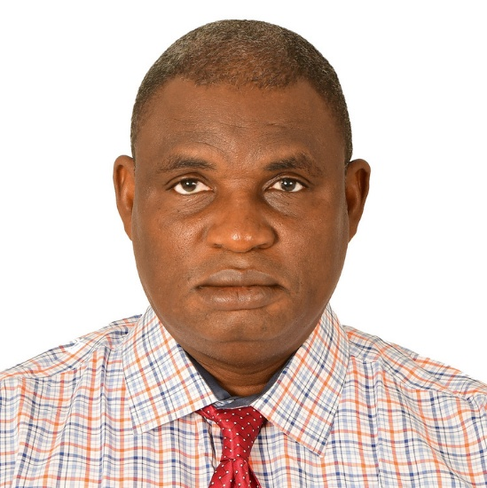
Outgoing Director, Prof. Amaza. handing
over leadership to the newly appointed
Director of the TCoEFS, Prof. Dauda Bawa.
In a significant leadership development, Prof. Tanko Ishaya, the Vice Chancellor of the University of Jos, has appointed Prof. Dauda Bawa as the new Director of TCoEFS. Prof. Bawa, a distinguished academic in Agricultural Extension and Rural Development, takes the helm at a critical juncture for the Centre. With over two decades of experience in rural development and agricultural technology, his leadership will guide TCoEFS in expanding its institutional partnerships and advancing innovative, climate-resilient agricultural practices across Nigeria.

Strategic Partnerships for Sustainable Agriculture
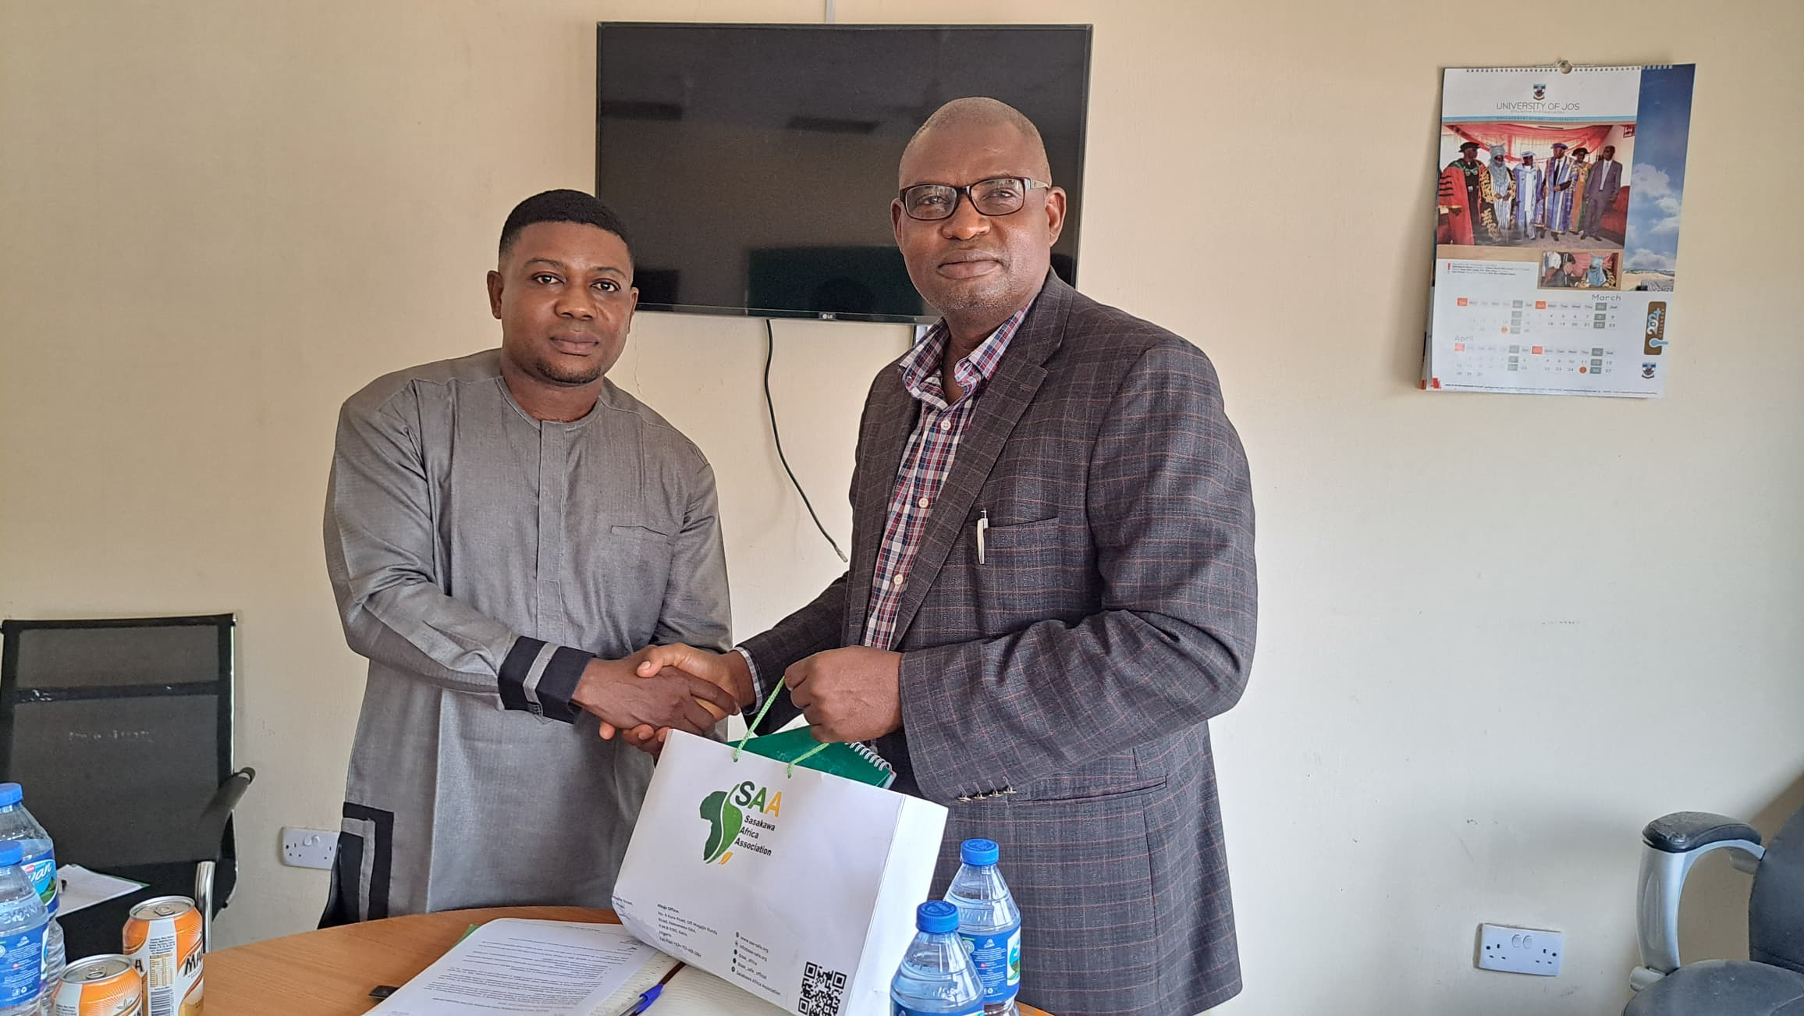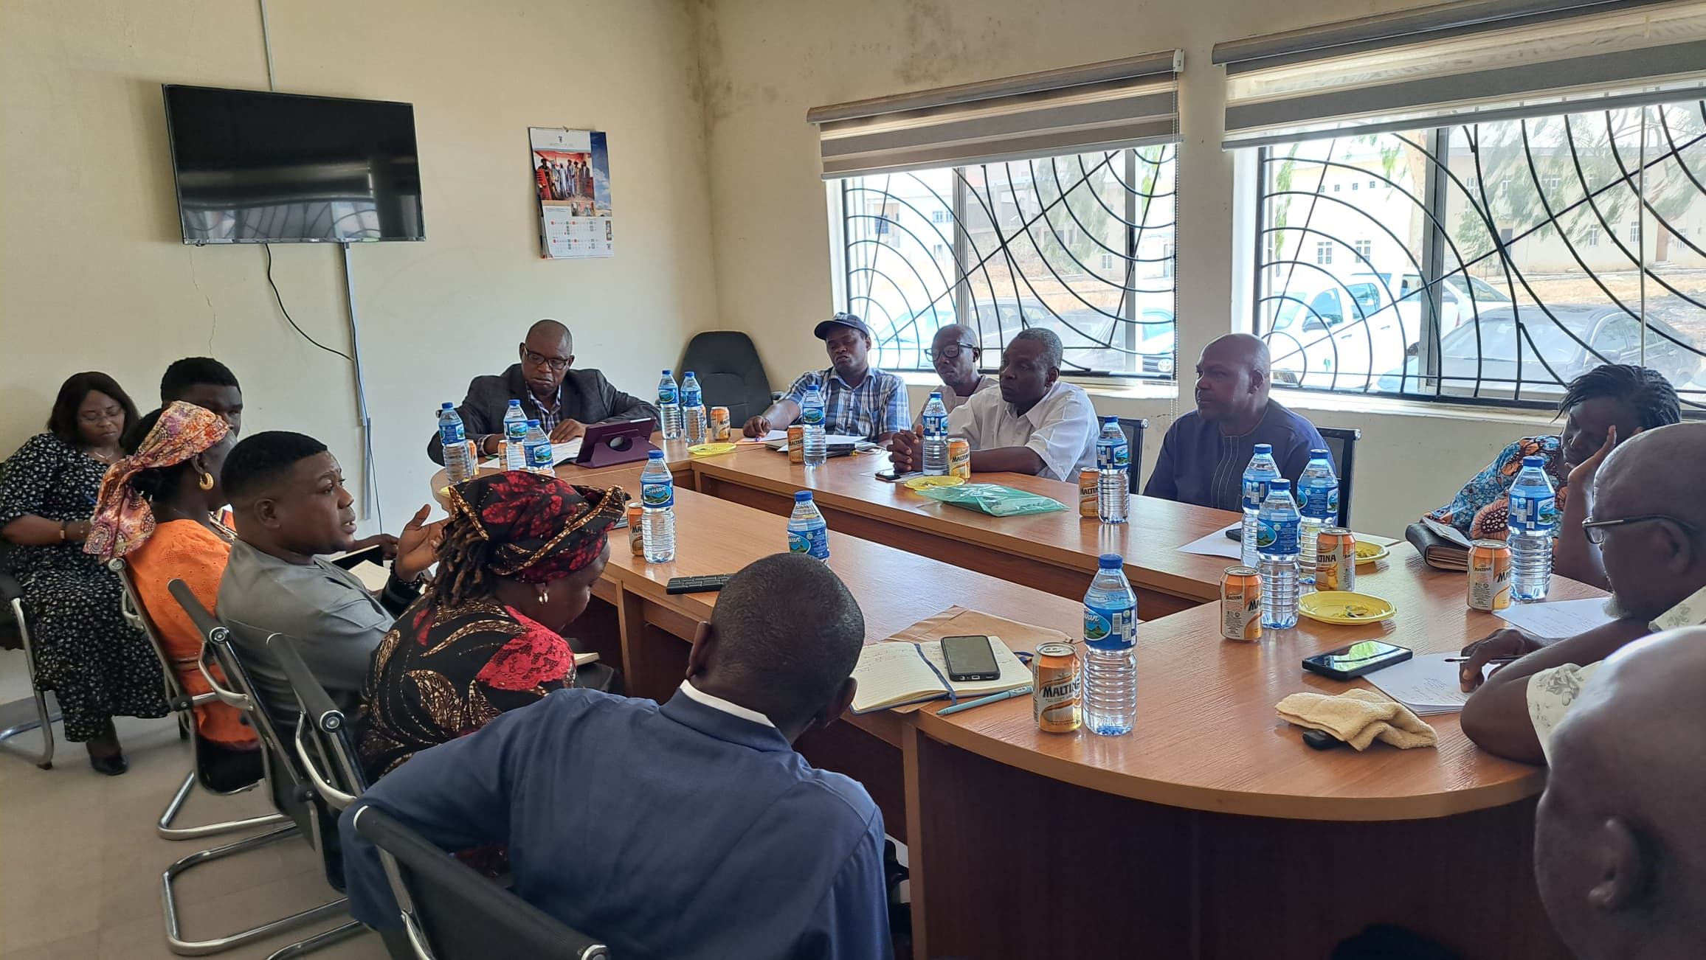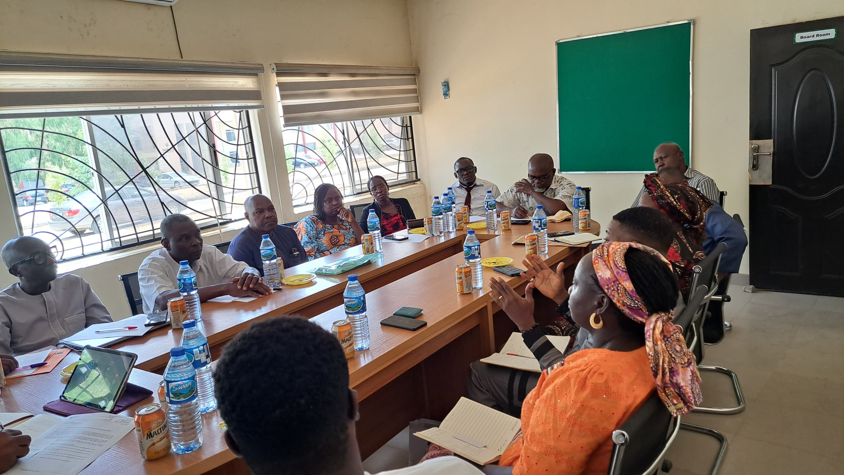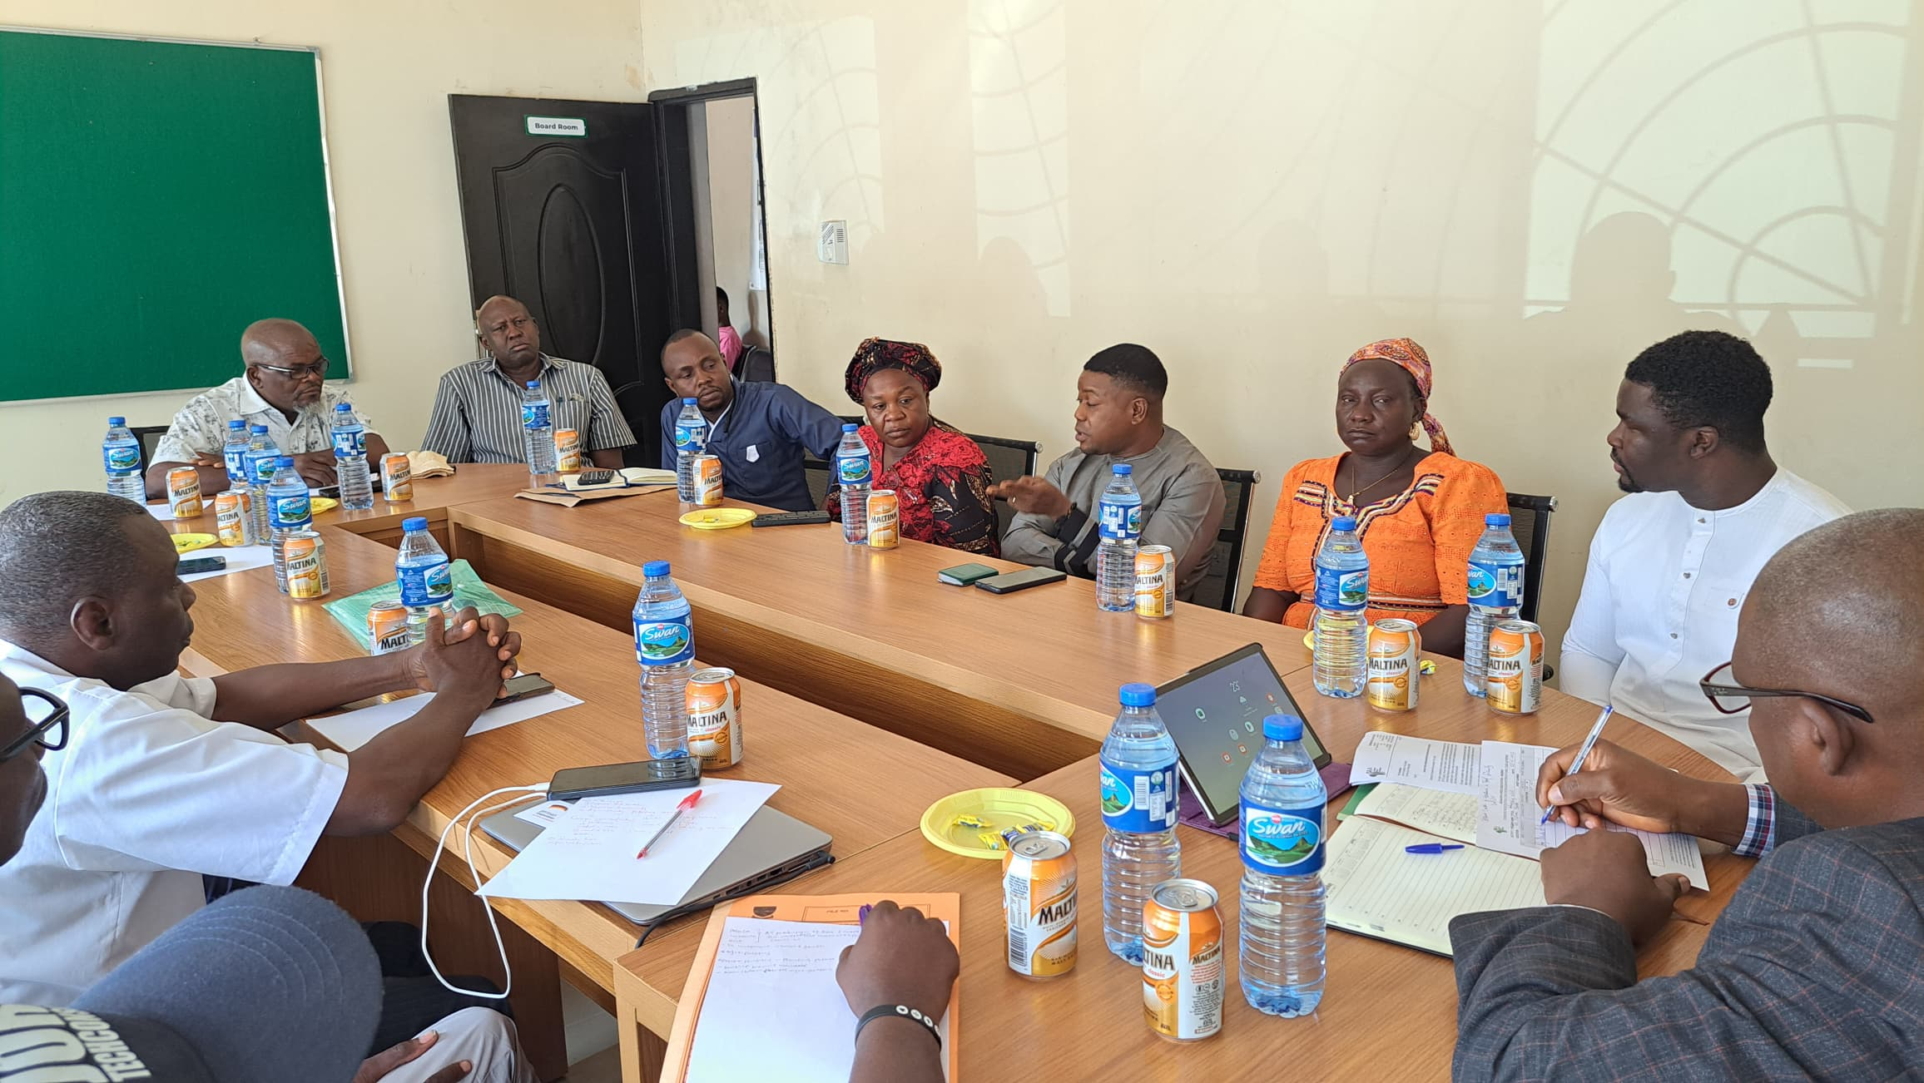
TCoEFS continues to build impactful partnerships to advance agricultural transformation in Nigeria. Recently, the Centre hosted a high-level engagement with the Sasakawa Africa Association (SAA) and the German Development Cooperation (GIZ), under the SIFTAS Project – Strengthening Institutional Frameworks for Transformative Agricultural Systems in Nigeria. This collaboration focuses on integrating climate-smart agriculture, with a particular emphasis on regenerative potato agroforestry. The partnership aims to enhance productivity, restore degraded lands, and promote sustainable practices to mitigate the challenges of climate change.

Advancing Food Security Through Innovation and Research
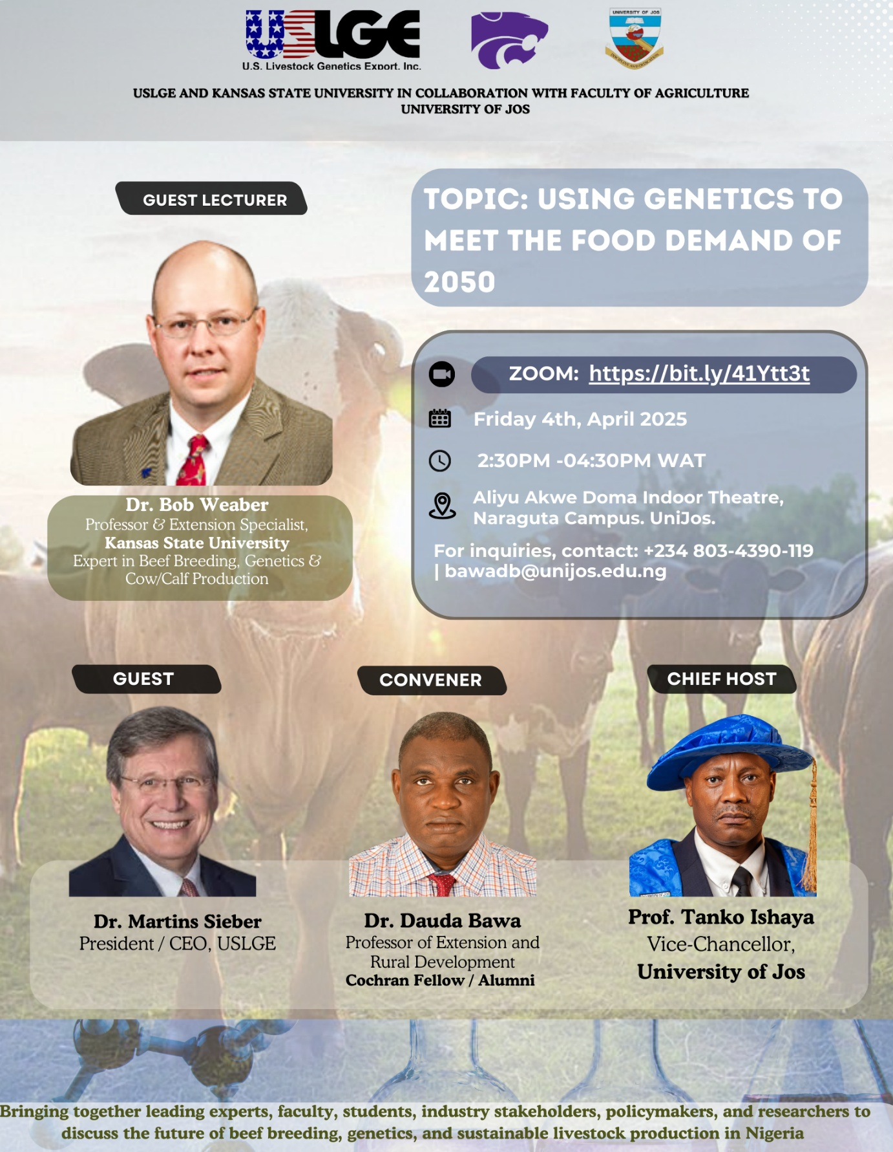

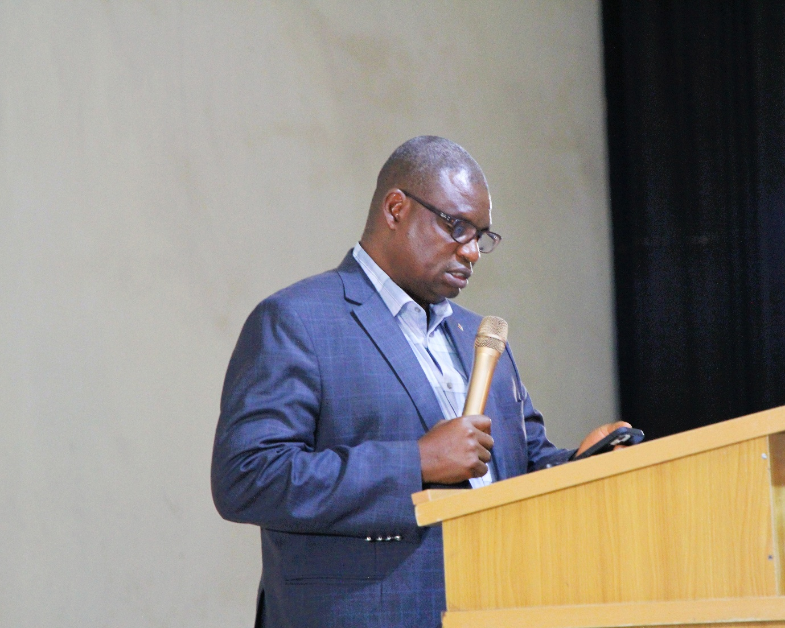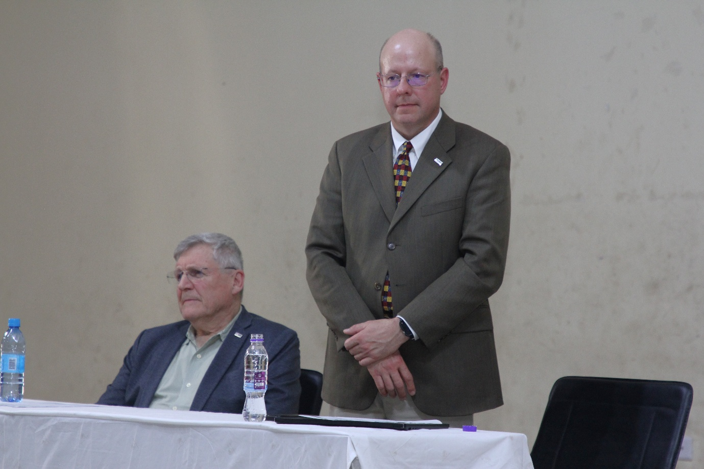
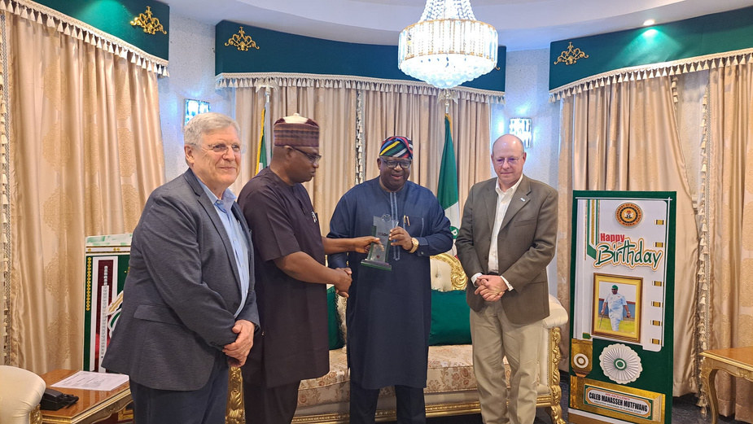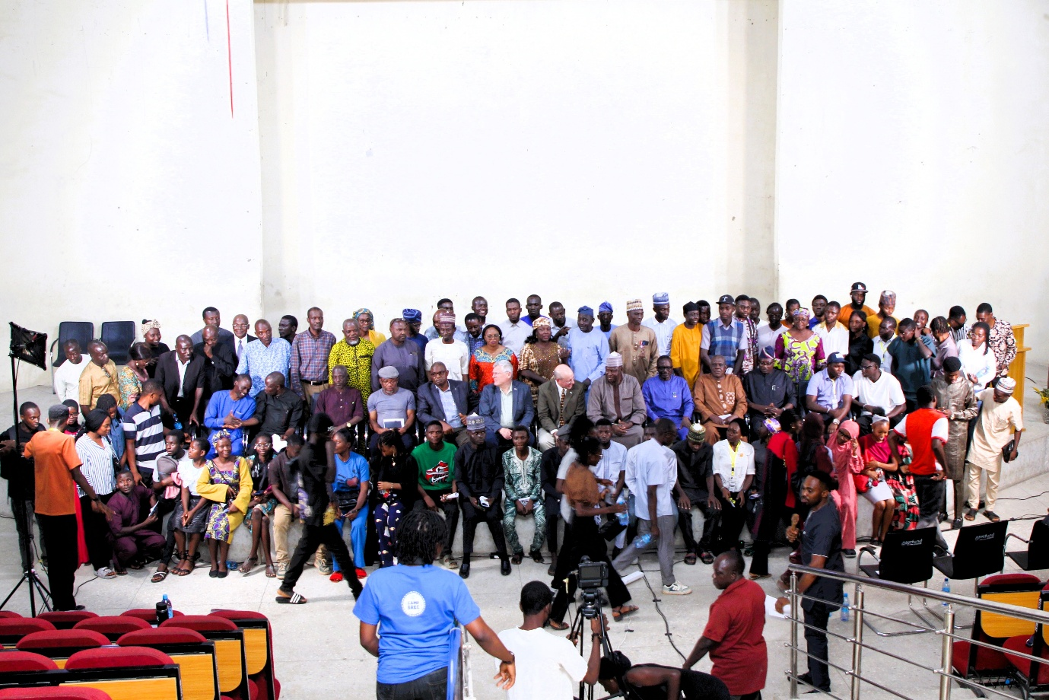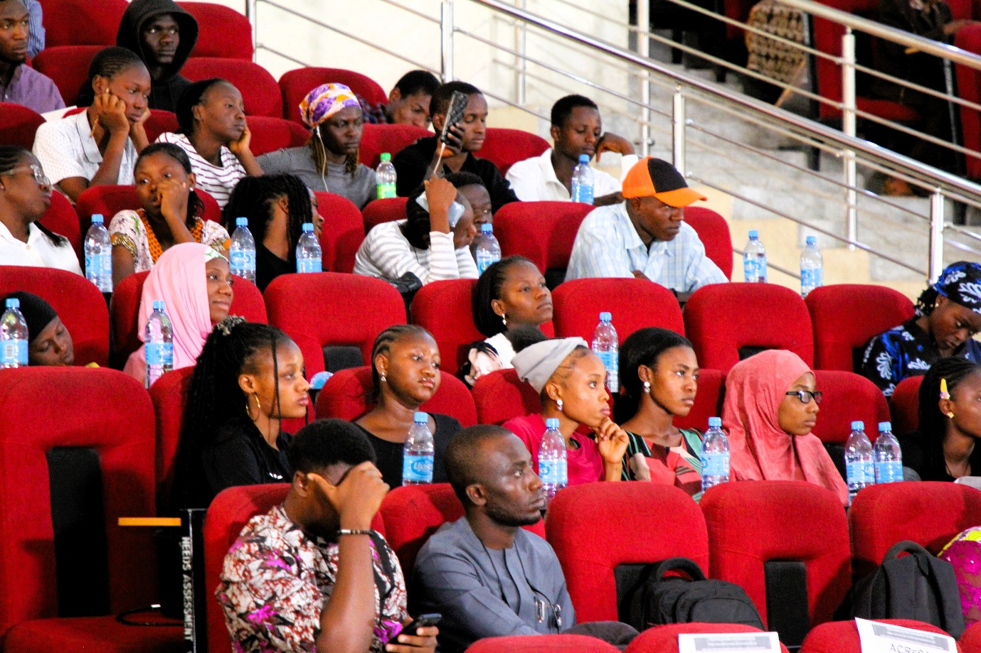
In line with its commitment to evidence-based solutions, TCoEFS organized a high-impact international lecture on April 4, 2025, titled "Using Genetics to Meet the Food Demand of 2050." The lecture, led by Dr. Bob Weaber from Kansas State University, highlighted the crucial role of genetic advancements in meeting the growing food demands of a global population expected to exceed 9.7 billion by 2050. The session covered the significance of genetic selection for climate-adaptable livestock, improving feed efficiency, and reducing greenhouse gas emissions, reinforcing the importance of animal genetics in achieving sustainable food systems.

TCoEFS: A Centre for Transformational Change
At the heart of Nigeria's agricultural transformation, TCoEFS remains committed to fostering research that not only contributes to academic discourse but also delivers practical solutions for farmers and policymakers. Through strategic collaborations, curriculum reforms, and evidence-based advocacy, the Centre is actively shaping the future of agriculture, promoting climate-resilient systems, and supporting Nigeria's sustainable food security agenda.



Don’t miss the gallery from April’s events — Also now live on our LinkedIn page!

